LAPORAN TUGAS
WORKSHOP SISTEM INFORMASI WEB SERVER
(TIF330805)
MINGGU KE-8 Pertemuan 1
SEMESTER III



ACARA 15
Konsep API dan JSON

Disusun Oleh :

Rezza Wahyu Setya Adhy (E41250211)
Golongan A

PROGRAM STUDI DI LUAR KAMPUS UTAMA (PSDKU)
TEKNIK INFORMATIKA KAB. NGANJUK
JURUSAN TEKNOLOGI INFORMASI
POLITEKNIK NEGERI JEMBER
TAHUN 2026
- Studi Kasus Membuat API Sederhana dan Response JSON
Buatlah API Data Mahasiswa yang dapat digunakan oleh aplikasi lain untuk mengambil data mahasiswa. Langkah Praktikum
- Langkah Praktikum
- Buat database dan table
- Buat endpoint API
- code public/api/mahasiswa.php, lalu SS hasil JSON di browser
<?php

require_once __DIR__ . '/../../app/Core/Database.php';
require_once __DIR__ . '/../../app/Core/Logger.php';

use App\Core\Database;
use App\Core\Logger;

// Memberi tahu client bahwa response berupa JSON
header('Content-Type: application/json; charset=utf-8');

try {
$pdo = Database::getInstance();
$stmt = $pdo->query("SELECT id, nim, nama, email FROM mahasiswa ORDER BY id");
$data = $stmt->fetchAll();

echo json_encode([
'success' => true,
'message' => 'Data berhasil diambil',
'data' => $data,
], JSON_PRETTY_PRINT | JSON_UNESCAPED_UNICODE);
} catch (Throwable $e) {
Logger::error($e->getMessage(), ['aksi' => 'api/mahasiswa.php']);
http_response_code(500);

echo json_encode([
'success' => false,
'message' => 'Terjadi kesalahan pada server',
'data' => null,
], JSON_PRETTY_PRINT);
}

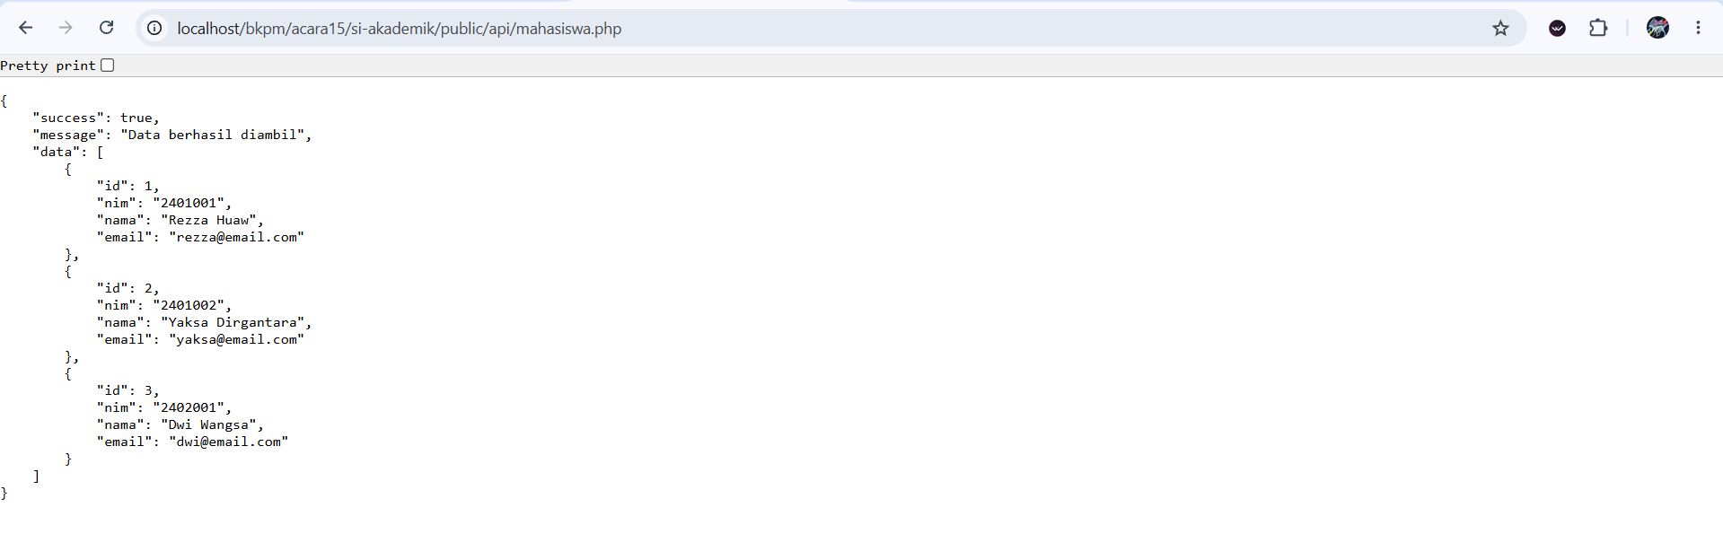
- Buat koneksi PDO
- app/Controllers/ApiMahasiswaController.php
<?php

namespace App\Controllers;

use App\Core\Logger;
use App\Services\MahasiswaService;
use Throwable;

class ApiMahasiswaController
{
public function __construct(private MahasiswaService $service)
{
}

// GET /api/mahasiswa -> semua mahasiswa
// GET /api/mahasiswa?id=1 -> satu mahasiswa
// GET /api/mahasiswa?q=budi -> pencarian nama / NIM
public function index(): void
{
try {
if (isset($_GET['id'])) {
if (!ctype_digit((string) $_GET['id'])) {
$this->json(400, false, 'ID harus berupa angka');
}

$mhs = $this->service->find((int) $_GET['id']);

if ($mhs === null) {
$this->json(404, false, 'Mahasiswa dengan ID ' . (int) $_GET['id'] . ' tidak ditemukan');
}

$this->json(200, true, 'Data berhasil diambil', $this->format($mhs));
}

$daftar = $this->service->all(trim($_GET['q'] ?? ''));
$this->json(200, true, 'Data berhasil diambil', array_map([$this, 'format'], $daftar));
} catch (Throwable $e) {
$this->error($e, 'GET /api/mahasiswa');
}
}

// POST /api/mahasiswa (body JSON)
public function store(): void
{
$input = json_decode(file_get_contents('php://input'), true);

if (!is_array($input)) {
$this->json(400, false, 'Body harus berupa JSON yang valid');
}

// Angkatan boleh dikosongkan: diambil dari 2 digit pertama NIM (23004 -> 2023)
if (!isset($input['angkatan']) && isset($input['nim']) && preg_match('/^\d{2}/', (string) $input['nim'], $m)) {
$input['angkatan'] = 2000 + (int) $m[0];
}

try {
$hasil = $this->service->create($input);

if (!$hasil['success']) {
$this->json(422, false, 'Data tidak valid', null, $hasil['errors']);
}

$baru = $this->service->find($hasil['id']);
$this->json(201, true, 'Data berhasil ditambahkan', $this->format($baru));
} catch (Throwable $e) {
$this->error($e, 'POST /api/mahasiswa');
}
}

// ===== Helper =====

// Hanya field yang perlu dikirim ke client
private function format(array $m): array
{
return [
'id' => (int) $m['id'],
'nim' => $m['nim'],
'nama' => $m['nama'],
'email' => $m['email'],
'prodi_id' => (int) $m['prodi_id'],
'prodi' => $m['prodi'],
'angkatan' => (int) $m['angkatan'],
'status' => $m['status'],
];
}

private function error(Throwable $e, string $aksi): void
{
Logger::error($e->getMessage(), ['aksi' => $aksi]);
$this->json(500, false, 'Terjadi kesalahan pada server');
}

// Mengirim response JSON terstruktur lalu menghentikan eksekusi
private function json(int $code, bool $success, string $message, mixed $data = null, array $errors = []): void
{
http_response_code($code);
header('Content-Type: application/json; charset=utf-8');

$body = ['success' => $success, 'message' => $message, 'data' => $data];

if (!empty($errors)) {
$body['errors'] = $errors;
}

echo json_encode($body, JSON_PRETTY_PRINT | JSON_UNESCAPED_UNICODE);
exit;
}
}
- Ambil data mahasiswa
- routes/web php
<?php

use App\Core\Middleware\AuthMiddleware;

$auth = [AuthMiddleware::class];

$routes = [
'GET' => [
'/' => ['HomeController', 'index'],
'/login' => ['AuthController', 'loginForm'],
'/logout' => ['AuthController', 'logout'],
'/dashboard' => ['DashboardController', 'index', 'middleware' => $auth],

'/mahasiswa' => ['MahasiswaController', 'index', 'middleware' => $auth],
'/mahasiswa/create' => ['MahasiswaController', 'create', 'middleware' => $auth],
'/mahasiswa/{id}' => ['MahasiswaController', 'show', 'middleware' => $auth],
'/mahasiswa/{id}/edit' => ['MahasiswaController', 'edit', 'middleware' => $auth],

'/prodi' => ['ProdiController', 'index', 'middleware' => $auth],
'/prodi/create' => ['ProdiController', 'create', 'middleware' => $auth],
'/prodi/{id}/edit' => ['ProdiController', 'edit', 'middleware' => $auth],

'/matakuliah' => ['MatakuliahController', 'index', 'middleware' => $auth],
'/matakuliah/create' => ['MatakuliahController', 'create', 'middleware' => $auth],
'/matakuliah/{id}/edit' => ['MatakuliahController', 'edit', 'middleware' => $auth],

'/api/mahasiswa' => ['ApiMahasiswaController', 'index'],
],
'POST' => [
'/login' => ['AuthController', 'login'],

'/mahasiswa' => ['MahasiswaController', 'store', 'middleware' => $auth],
'/mahasiswa/{id}/update' => ['MahasiswaController', 'update', 'middleware' => $auth],
'/mahasiswa/{id}/delete' => ['MahasiswaController', 'destroy', 'middleware' => $auth],

'/prodi' => ['ProdiController', 'store', 'middleware' => $auth],
'/prodi/{id}/update' => ['ProdiController', 'update', 'middleware' => $auth],
'/prodi/{id}/delete' => ['ProdiController', 'destroy', 'middleware' => $auth],

'/matakuliah' => ['MatakuliahController', 'store', 'middleware' => $auth],
'/matakuliah/{id}/update' => ['MatakuliahController', 'update', 'middleware' => $auth],
'/matakuliah/{id}/delete' => ['MatakuliahController', 'destroy', 'middleware' => $auth],

'/api/mahasiswa' => ['ApiMahasiswaController', 'store'],
],
];
- Ubah hasil query menjadi JSON
public/api/mahasiswa.php
$pdo = Database::getInstance();
$stmt = $pdo->query("SELECT id, nim, nama, email FROM mahasiswa ORDER BY id");
$data = $stmt->fetchAll();

echo json_encode([
'success' => true,
'message' => 'Data berhasil diambil',
'data' => $data,
], JSON_PRETTY_PRINT | JSON_UNESCAPED_UNICODE);
- Buat response yang lebih terstruktur
public/api/mahasiswa.php
echo json_encode([
'success' => false,
'message' => 'Terjadi kesalahan pada server',
'data' => null,
], JSON_PRETTY_PRINT);

- Uji API
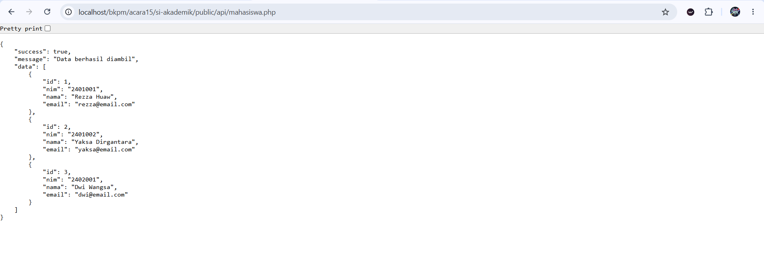
- Tugas Pengembangan
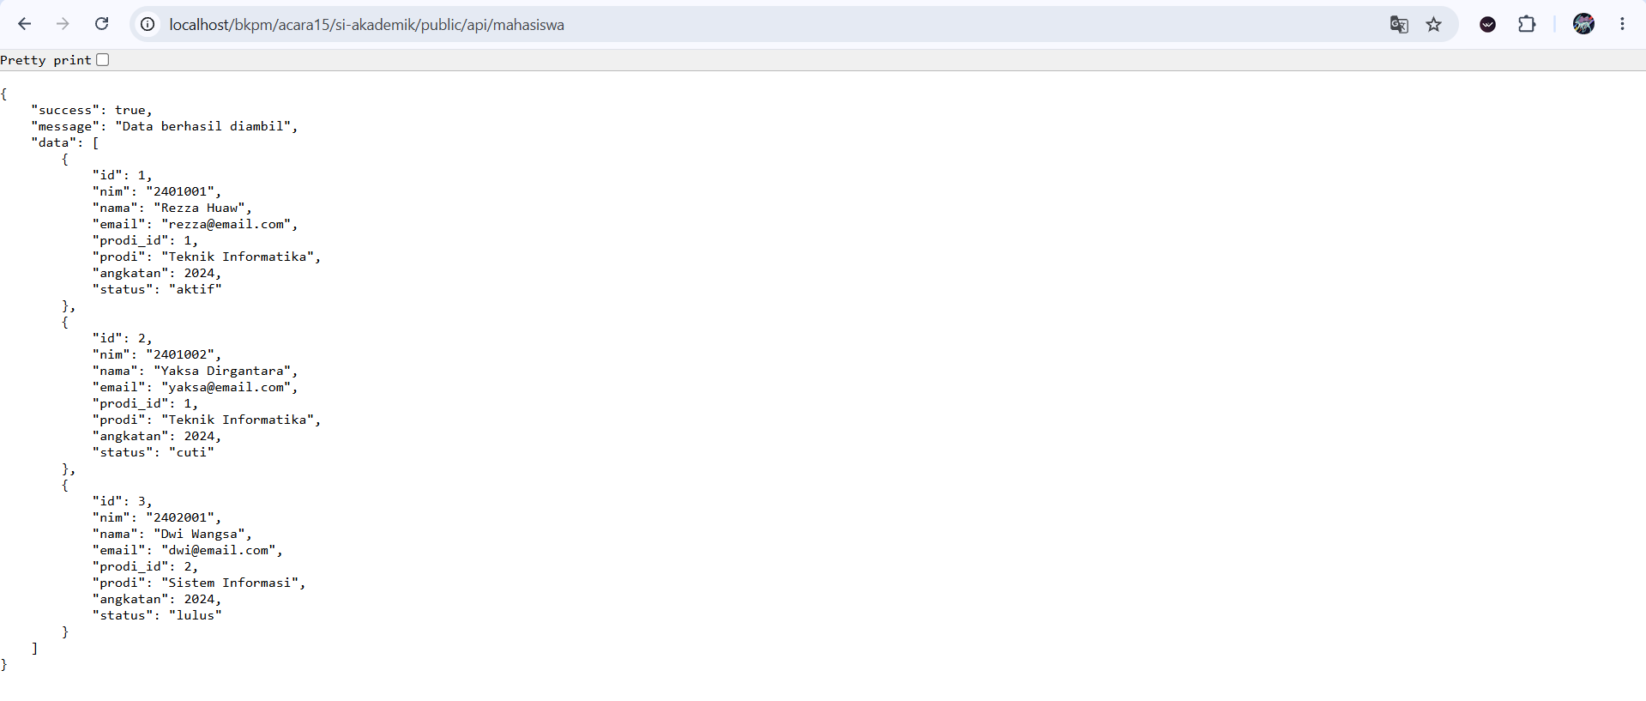
- Tes dengan Postman
- http://localhost/bkpm/acara15/si-akademik/public/api/mahasiswa.php
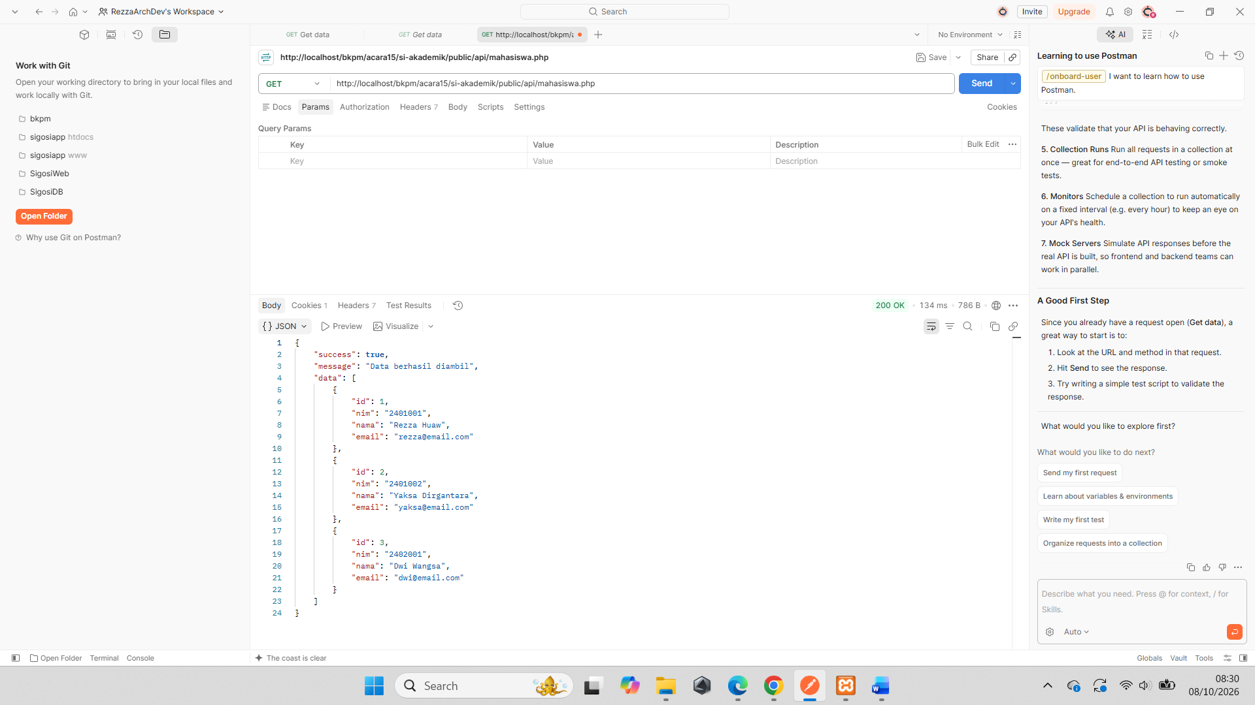

- http://localhost/bkpm/acara15/si-akademik/public/api/mahasiswa (GET)
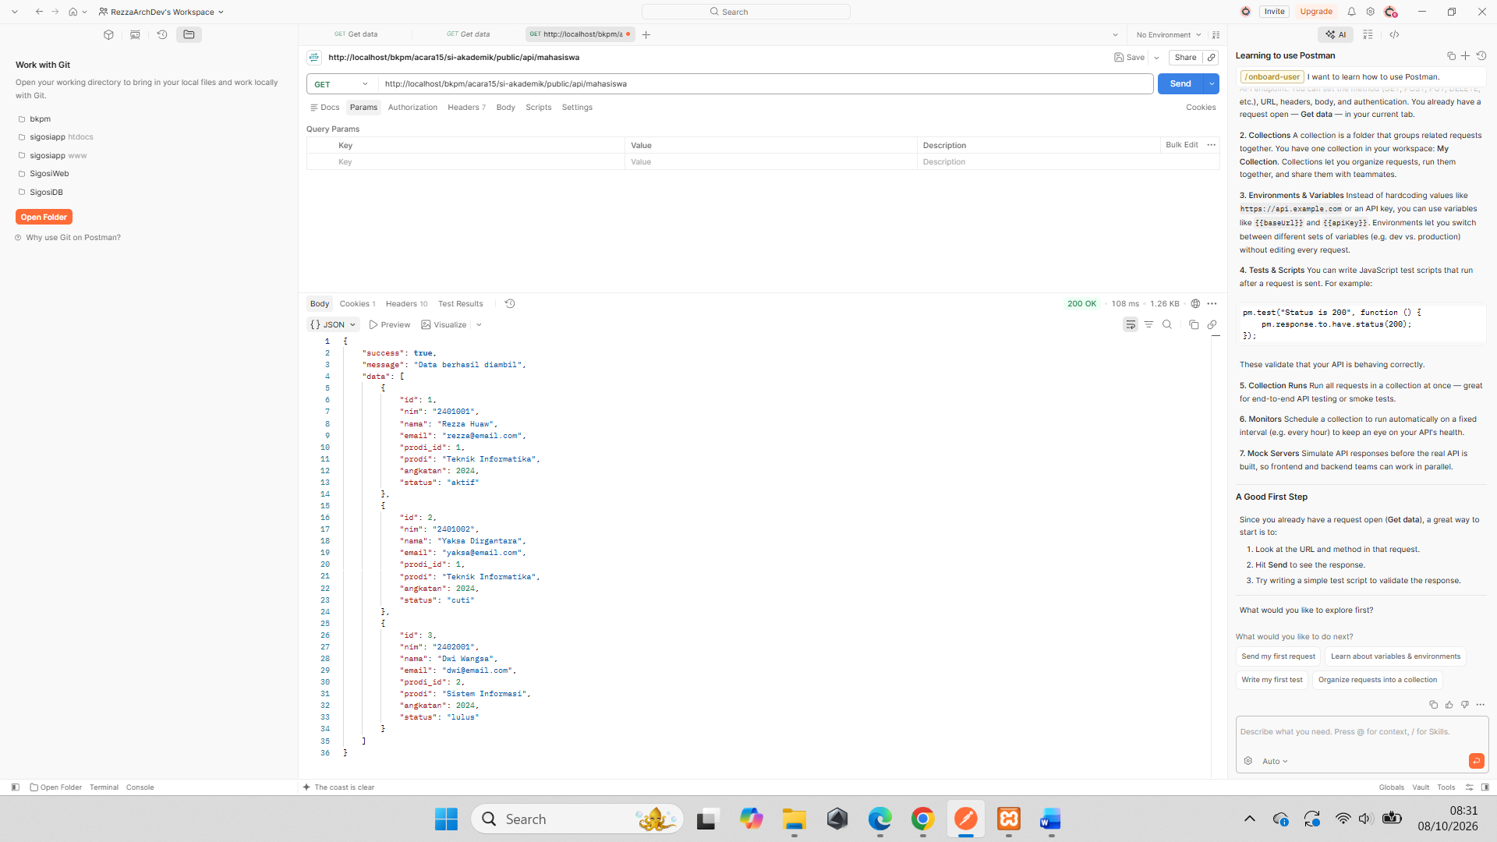
- http://localhost/bkpm/acara15/si-akademik/public/api/mahasiswa?id=1
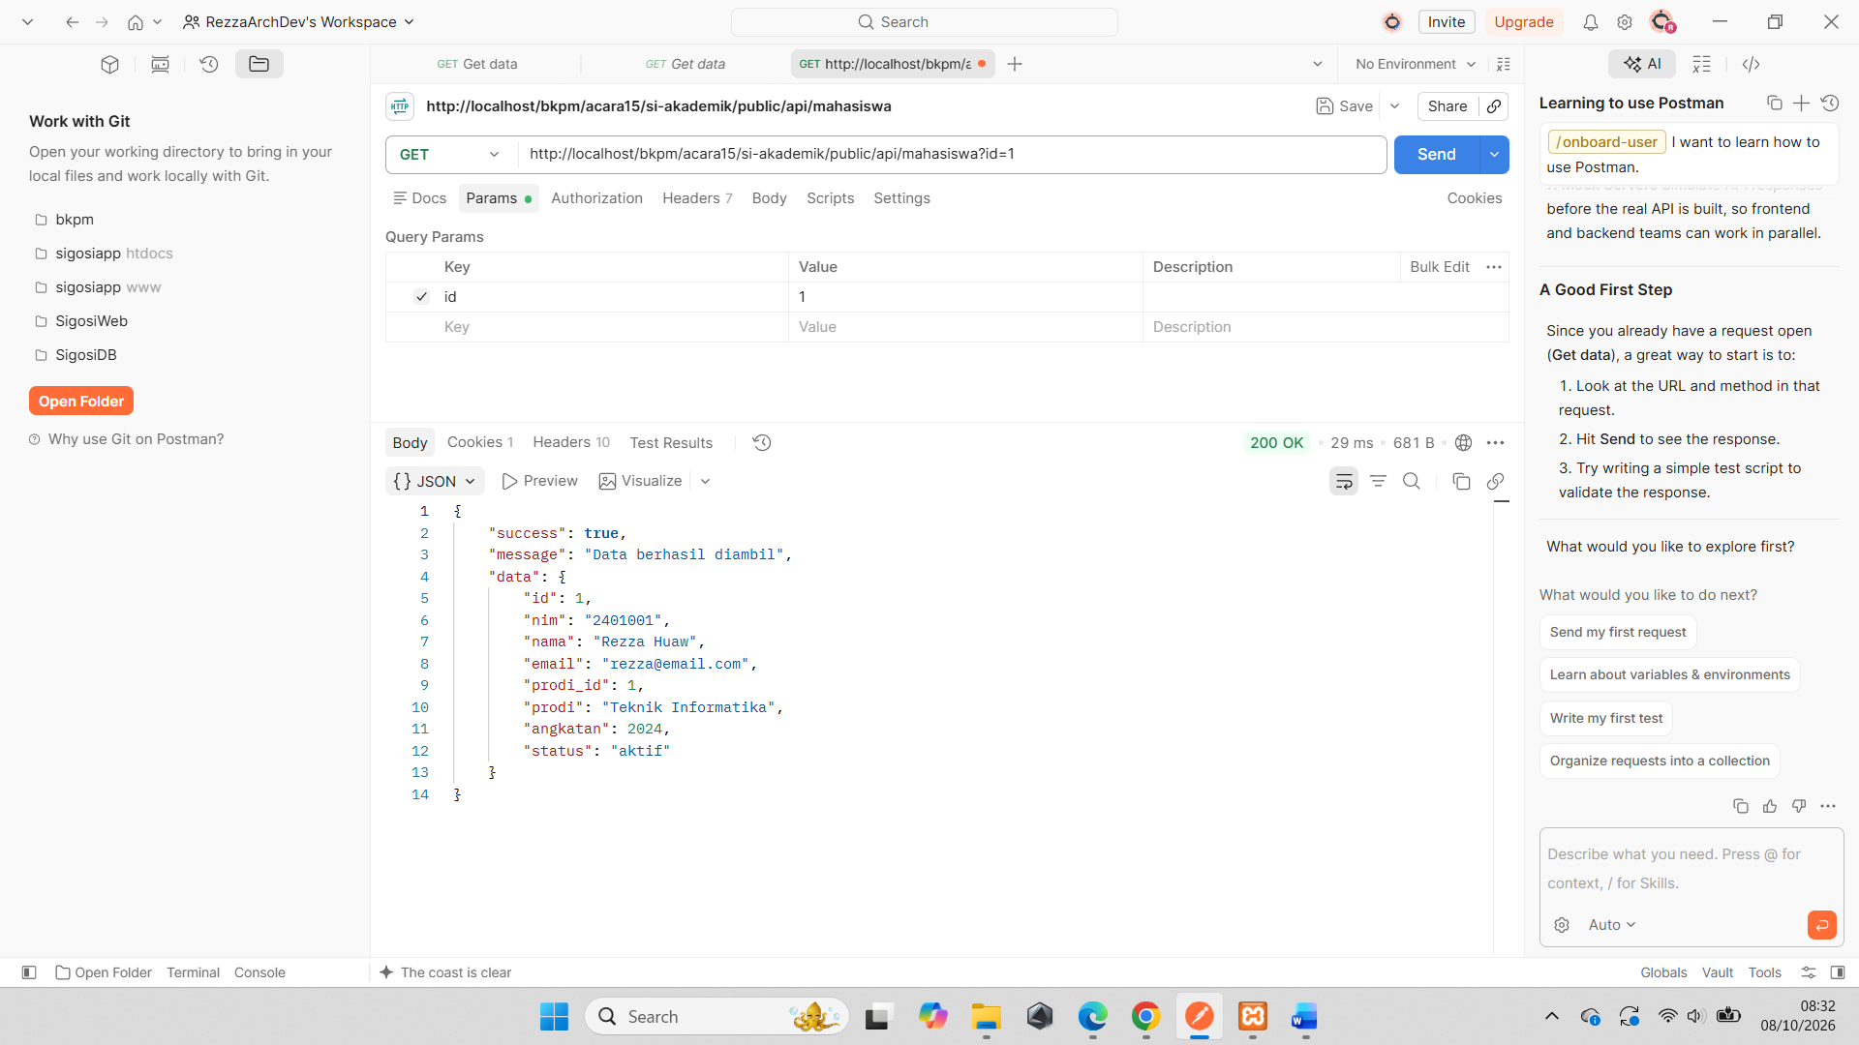
- http://localhost/bkpm/acara15/si-akademik/public/api/mahasiswa (POST)
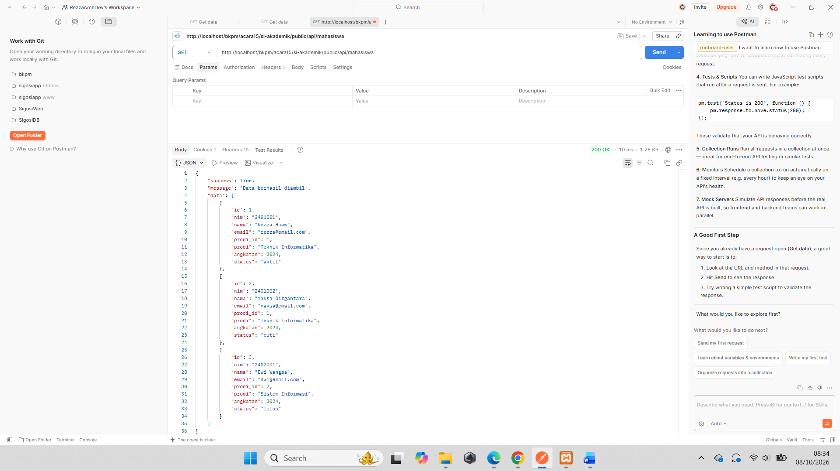

- Output Praktikum
Mahasiswa mengumpulkan:
- Source code API.
- Database MySQL.
- Screenshot pengujian menggunakan Postman.
- Contoh JSON response.
- Minimal endpoint GET dan POST berhasil dijalankan.

